Template and Instructions for Extended Abstracts of IBM 2025

First. A. Author🟎, Second. B. Author† and Third. C. Author††
*Business or Academic Affiliation, City, State, Pin/Zip Code.
† Business or Academic Affiliation, City, State, Pin/Zip Code.
°Business or Academic Affiliation, City, State, Pin/Zip Code.
*Corresponding author’s email: xxxx@xxxx.xxx

Extended Abstract
This document is a template for preparing the 2-page extended abstract for IBM 2025 using Microsoft Word 2003 or later. The styles and formats for the IBM 2025 template have been incorporated into the structure of this document. If you are using Microsoft Word, please use this template to prepare your manuscript. The extended abstracts will go through a peer review process and those accepted for presentation will present their research in Students’ Paper Contest Session in the conference.

Introduction
A general guide might be a total length of 2 A4 size pages including no more than 2 figures or tables and no more than 5 references. All texts should be single line spaced, in Calibri, 11pt font size consistently. The title is centred, bold Candara 14pt, authors names are centred, in bold font Calibri 12pt, and author affiliations are in Calibri 9pt (not bold). The first author should be the presenting author of the paper. The email address of the corresponding author (denoted with a *) must be provided. The Extended Abstract begins with a short abstract and ends with a conclusion section. This is concluded by a short list of no more than 5 selected references. Do not use foot notes. Leave one space between two sentences. The submission of extended abstract is coterminous with the last of registration for IBM 2025. The extended abstract shall be peer reviewed by an expert committee. Read the instruction for Students’ Paper Contest carefully in the IBM webpage.

Methods
This template provides authors with most of the formatting specifications needed for preparing their extended abstract. The extended abstract must be written in English. Text should be justified with 1 inch margin all around the text in A4 size paper. The extended abstract including figures, tables and references must have a maximum size of 2 pages. The main heading should be left aligned in bold faced 11pt. There should be a space before and 6pt space below after the main headings. The normal text within paragraph must be written single spaced justified in one column. References should be cited in the text as Escober et al¹ and Cuda et al².
The equations can be made using the equation editor. A displayed equation is numbered using Arabic numbers in parenthesis as shown in equation (1). The equation is 12pt font centred, with 6pt spacing above and below the equation to separate it from the surrounding text.

(1 + 𝑥)^{𝑛} = 1 +
𝑛𝑥 1!
𝑛(𝑛 − 1)𝑥²
+
2!
(1)

Results and Discussion

All figures should be numbered consecutively and captioned below the figure. The caption title should be written centred, with sentence case letters. The figures must be referenced in the text as Figure 1. Table caption should be at the top of the table. A sample figure and a table is shown below

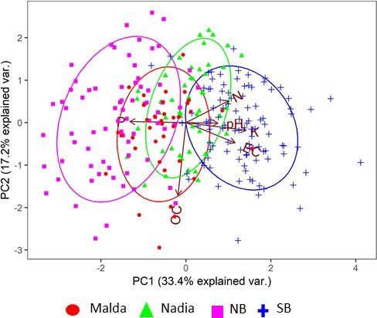
Figure 1. Figure caption Table 1. Table caption

Col head 1 | Col head 2 | Col head 3 | Col head 4
Row head 1 | 0.547 | 0.547 | 873.69
Row head 1 | 0.835 | 0.318 | 1069.4
Row head 1 | 0.971 | 0.202 | 1408
Row head 2 | 0.079 | 0.079 | 273.96
Row head 2 | 0.1952 | 0.157 | 495.96
Row head 2 | 0.3044 | 0.11 | 767.15

Conclusion
All tables should be numbered consecutively and captioned. A 6pt space should separate the table from the caption, and a 6pt space should separate the upper part of the table and the bottom of the caption from the surrounding text. The tables must be cited in the text as Table 1. A sample table is as shown below.

Acknowledgements
Extended Abstracts needs to be uploaded in the conference website during registration.

References
- Escobar, L. E., Qiao, H., Cabello, J. & Peterson, A. T. Ecological niche modelling re‐examined: A case study with the Darwin's fox. Ecology and evolution 8, 4757-4770 (2018).
- Cuda, J. P. et al. Laboratory biology and impact of a stem boring weevil Apocnemidophorus pipitzi (Coleoptera: Curculionidae) on Schinus terebinthifolia. Biocontrol Science and Technology, 1-33 (2016).

